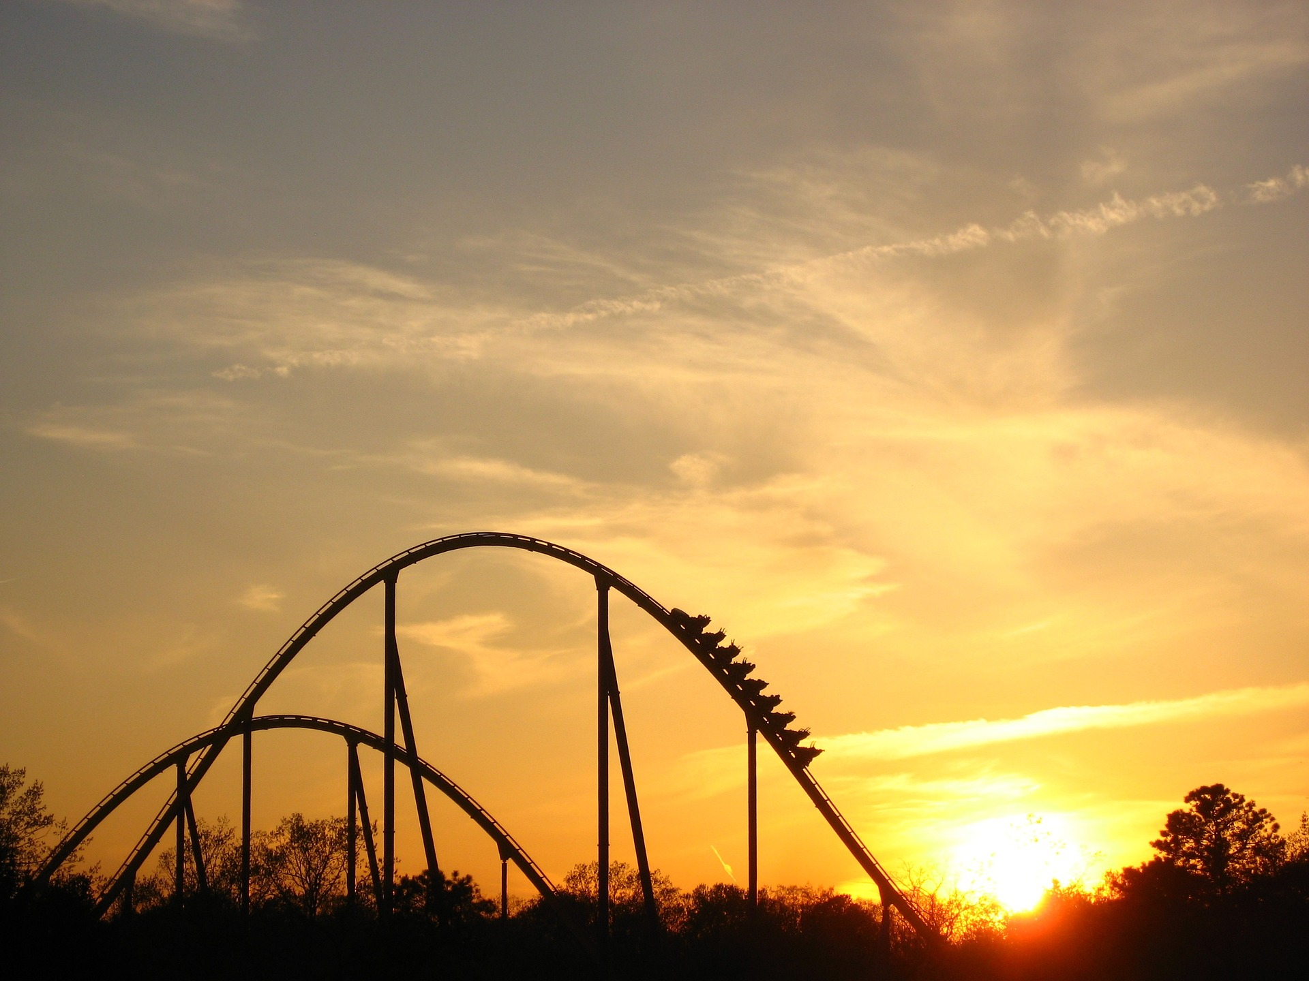

Lesson 2: Gravitational potential energy
Keywords: potential energy, mass, height, gravitational field strength

Objectives:
A) Define gravitational potential energy
B) Calculate gravitational potential energy, mass & height


C) Convert between gravitational potential energy and kinetic energy
Objective A: Defining gravitational potential energy
Starter
Look at the picture above. Can you describe the energy transfers that occur during this rollercoaster ride?

When will the riders have the most gravitational potential energy? When will they have the least? What about their kinetic energy?

Objective A: Defining elastic potential energy

Gravitational potential energy (GPE) is the energy an object has due to being raised above the ground.

Gravitational potential energy, in joules (J)
Mass, in kilograms (kg)
Gravitational field strength, in newtons per kilogram (N/kg)
Height above the ground, in metres (m)

Practice A: Defining gravitational potential energy
1. State the equation for gravitational potential energy, defining the symbols you use.

2. Write a sentence describing gravitational potential energy in words

3. Rank the following from low to high kinetic energy: a rhino balancing on a ball, an egg on a kitchen work top, a person in a hot air balloon.

4. Explain two ways that the gravitational potential energy of a pigeon could be increased.
Assessment A: Defining gravitational potential energy

Which statements are true, and which are false?

A | Gravitational potential energy is directly proportional to mass
B | In a mechanic’s garage, a motorbike and a truck are both jacked 1 m above the floor. The motorbike stores more GPE than the truck.
C | Gravitational potential energy is stored by doing work against the gravitational force.
D | During an experiment, I lift a Newton meter 1 m above the earth. If I do the same experiment on the moon, I will store less GPE in the Newton meter.

Objective B: Calculate GPE, mass & height
Objective B: Calculate GPE, mass & height

Worked example 1: Finding GPE

A diving platform is 10 m above the ground. When an 80 kg diver climbs to the top of the platform, how much GPE does he acquire?

Solution

In the question we are given that the mass is 80 kg, and the height is 10 m. If no value is given, we can assume that the gravitational field strength on the earth is 10 N/kg.

Using these values in the equation for GPE:

Worked example 2: Finding mass

The record for the highest hot air balloon flight is 21,027 m. At this height, the balloon had an estimated 735 MJ of GPE. What was the mass of the balloon?

Solution

Step 1: Rearrange the GPE equation to make mass the subject…

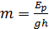

Step 2: Substitute in our known values for GPE, h and g…

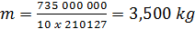

Worked example 3: Finding height

At what height would the same hot air balloon have 50 kJ of GPe?

Solution

Step 1: Rearrange the GPE equation to make height the subject…

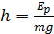

Step 2: Substitute in our known values for GPE, h and g…

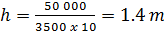
Practise B: Calculate GPE, mass & height

- Mass = 4.87 kg, height = 54 cm. Calculate the GPE

- Compare the gravitational potential energy of the motorbike and the truck from Part A. Take the truck’s mass to be 5000 kg, and the bike’s mass to be 120 kg.

- If a 6 kg eagle in flight has 900 J of GPE, how high is it flying above the earth? A smaller bird would have to travel at twice this height to store as much GPE. What is the mass of the smaller bird?

Assessment B: Calculate GPE, mass & height

Which statements are true, and which are false?

A | A 65 kg bungee jumper stood over a 80 m drop has 52000 J of GPE
B | A 130,000 kg jet plane must reach an altitude of 1 km to gain 1.3 GJ of GPE
C | Tom Cruise hangs off the edge of a 1.2 km – high cliff face. If he has 81 000 J of GPE then he must weigh 75 kg.
D | A bowling ball has a mass of 7 kg. If the gravitational field strength on the moon is 1.6 N/kg, how much GPE is stored when it is lifted 0.5 m from the moon’s surface?

Objective C: Convert between GPE and kinetic energy

Worked example 1:

Kris is at the top of a 5 m high slide. Assuming that all of her GPE is converted to KE, what will be her maximum speed when she reaches the bottom? Kris has a mass of 55 kg.

Solution

Step 1: Calculate Kris’s GPE at the top of the slide:

Step 2: As Kris slides down, her GPE is converted to KE. At the bottom of the slide, all her GPE will have been converted to KE, i.e. her KE equals 2750 J.

Next, rearrange the KE equation to find her speed:
Study tip
Here we assumed that all of the GPE was converted to KE. However, in the real world some energy would be dissipated as heat, due to friction and air resistance. This means that Kris’s true speed will be less than we have calculated here.

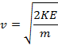

Step 2: Substitute our known values for m and KE:

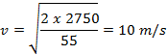

Worked example 2:

Roger Federer hits a tennis ball of mass 50 g directly upwards in the air, at a velocity of 25 m/s. What is the maximum possible height the ball could reach?
Study tip
Don’t forget to convert grams into kilograms to use the KE equation!

Solution

Step 1: Calculate the ball’s initial kinetic energy

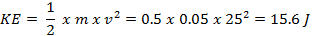

Step 2: The maximum possible height that the ball could reach would be if all this KE was converted to GPE, i.e the GPE becomes 15.6 J.

Next, rearrange the GPE equation for height:

Step 3: Substitute in the known values for GPE, mass, and gravitational field strength:

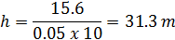

Did you know?

We don’t really need to know the mass to solve this problem!

We could have started by setting the KE and GPE equations equal to each other to get:

Notice that we have m on both sides, so we can cancel out a factor of m to get:

Then all we need to do is to rearrange this equation for the height…

…and finally, put in our known values!

Practise C: Convert between GPE and kinetic energy
- Dr Who chases a dangerous alien to the top of the Eiffel tower in Paris. If she were to drop her sonic screwdriver from this height, what is the maximum speed it could reach when it hits the floor? Ignore air resistance and assume that all the GPE is converted to KE. The Eiffel Tower is 300 m high, and the screwdriver has a mass of 113 grams.

- A bullet of mass 11.3 g is fired directly up into the air with an initial KE of 3.6 kJ. What is the bullet’s initial velocity? What is the maximum height the bullet could reach?

- Felix Baumgartner was the first human being to travel faster than sound, without the aid of a vehicle! He achieved this by jumping out of a hot air balloon at a height of 39 km. His total mass, (including his special space suit) was 120 kg.
How far did Felix fall before he broke the sound barrier? Sound travels at 343 m/s.
Assessment C: Convert between GPE and kinetic energy
An irresponsible tourist drops a penny of mass 2.5 g from the top of the Burj Khalifa in Dubai. The Burj Khalifa is 828 m high.

Which statements are true, and which are false?

A | The penny’s GPE at the top of the Burj Khalifa is 20.7 kJ
B | The penny’s GPE at the top of the Burj Khalifa is 20.7 J
C | The maximum velocity of the penny as it hits the ground is 16.5 km/s
D | The maximum velocity of the penny as it hits the ground is 0.129 km/s

